|  |  |  |
| --- | --- | --- |
|  | **Datchet Parish Council** | 1 Allen Way  Datchet  Berkshire  SL3 9HR |

Web: [www.datchetparishcouncil.gov.uk](http://www.datchetparishcouncil.gov.uk) **Sonia Masikito - Clerk to the Council**

Email: Clerk@datchetparishcouncil.gov.uk

Tel: 01753 773499

To: Environment Agency

Surrey County Council

Planning Inspectorate

cc RBWM

Date: 15/12/2023

To whom it may concern

**RIVER THAMES SCHEME**

At the Datchet Parish Council Meeting held on Monday 11/12/2023 the following motion was approved unanimously.

**To approve that Datchet Parish Council writes to the Environment Agency, Surrey County Council and the Planning Inspectorate (with cc. to RBWM) to record their INTENTION TO OBJECT to the River Thames Scheme Development Consent Order application.**

Kind Regards

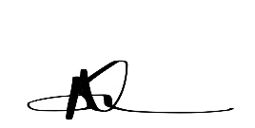

Sonia Masikito

Clerk to the Council

Datchet Parish Council