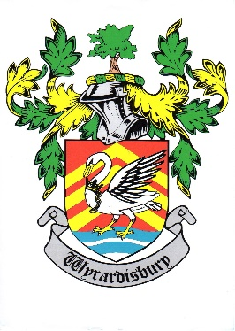*Wraysbury Parish Council*

***Wraysbury Public Flood Meeting***

*will be held in the Wraysbury Village Hall on,*

***TUESDAY 30TH JANUARY 2024***

***at 7.00pm***

***AGENDA***

1. **Objectives**

* Share Data
* Communicate Progress
* Gather feedback
* Make decisions

1. **INTRODUCTIONS**
2. **WRAYSBURY FLOOD WARDEN - SUMMARY**
3. **OVERVIEW AND UPDATES REPRESENTATIVES FROM:**

**• ENVIRONMENT AGENCY**

**• THAMES WATER**

• RBWM

1. QUESTIONS FROM THE PUBLIC
2. PRESENTATION
3. DRAFT PROPOSALS FOR MOTIONS

**• REINSTATEMENT OF RIVER THAMES SCHEME CHANNEL ONE**

**• CLEARANCE AND UNBLOCKING OF WRAYSBURY DRAIN**

**• REINSTATEMENT OF MAIN RIVER DREDGING IN THE RIVER THAMES**

**Fire Alarm** - In the event of the fire alarm sounding or other emergency, please leave the building quickly and calmly by the nearest exit. Do not stop to collect personal belongings. Congregate in the WVH Car Park. Do not re-enter the building until told to do so by a member of staff.

**Recording of Meetings** – The Council allows the filming, recording and photography of public Council meetings. This may be undertaken by the Council itself, or any person attending the meeting. By entering the meeting room you are acknowledging that you may be audio or video recorded.