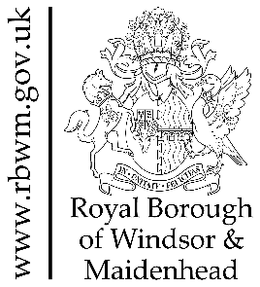
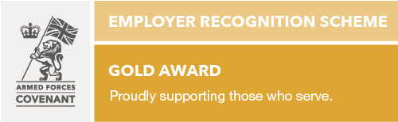
Cllr Richard Coe
Cabinet Member for Household & Regulatory Services
Cllr.Coe@rbwm.gov.uk

The Rt Hon Steve Barclay MP
Secretary of State for Environment,
Food & Rural Affairs
DEFRA, Nobel House
17 Smith Square
London SW1P 3JR

The Rt Hon Lord Benyon PC
Minister of State for Climate,
Environment & Energy
DEFRA, Nobel House
17 Smith Square
London SW1P 3JR

Email to: defra.helpline@defra.gsi.gov.uk

19 April 2024

Funding for the ‘Berkshire Channel’ River Thames flood alleviation scheme

Dear Sirs,

The Royal Borough of Windsor and Maidenhead recently responded to the statutory consultation led by the Environment Agency relating to the River Thames Scheme as it progresses through the Development Consent Order process.

The impact of flooding on communities close to the Thames is significant in terms of the health, social and economic effects. With the impact of climate change, these risks are only increasing and flooding events becoming more frequent.

As a Borough, many of our communities were impacted significantly by widespread flooding in 2014 - referenced several times in the consultation documents - and more recently in January this year following the significant rainfall during Storm Henk.

As currently envisaged, the overall vision for the River Thames Scheme is incomplete and represents a missed opportunity. Put simply, without the Berkshire Channel (previously known as ‘Channel One’) being included in the scheme, there are many communities in our Borough which will not see significant flood relief or the wider environmental and economic benefits which the original scheme was intended to deliver.

The Berkshire Channel was designed to divert water from the Thames and ran from Southlea Road in Datchet, passed through Datchet, Horton and Wraysbury lakes and re-entered the Thames downstream of Bell Weir at Hythe End – a channel of approximately 7km in length. Estimates we have seen put the cost at approximately £120m - £150m. Tens of millions have been spent on the River Thames Scheme to date, and it is crucial that the scheme delivers its original intentions, with the Berkshire Channel included.

As flooding events become a more regular occurrence, they will have a devastating impact on the Royal Borough, with the areas of Datchet, Horton, Wraysbury and Old Windsor seeing some of the most significant impacts. There are nearly 7,000 households across these villages which remain unprotected and therefore at risk.

Town Hall, St. Ives Road, Maidenhead, SL6 1RF
www.rbwm.gov.uk customer.service@rbwm.gov.uk 01628 683800
@rbwm search: rbwm

To ensure communities in the Royal Borough are better protected from future flooding events, it is our firm belief that the previously proposed Berkshire element of the scheme must be delivered in full. The Berkshire Channel section was removed due to challenges around local funding, and the increased pressure on local government funding since then have made the possibility of local funding even more unrealistic.

Unitary Authorities simply are not funded to deliver flood alleviation schemes to the scale of what is needed to protect our local communities. Indeed, the requirement for partnership funding was only introduced in 2011, some years after the River Thames Scheme had commenced and which constituted a significant moving of the goalposts.

That aside, this is clearly an infrastructure scheme of national significance which should therefore be delivered through national funding. This is why the Royal Borough of Windsor and Maidenhead and the Parishes of Datchet, Horton, Wraysbury and Old Windsor are jointly requesting that the Environment Agency – and by extension central Government - commit to funding the Thames flood alleviation proposals in full, including the Berkshire Channel.

This request also recognises that the proposal represents an issue of national importance which - as stated in the wider Thames Scheme vision - will enhance the resilience of nationally important infrastructure. This stretch of the Thames also carries water which has travelled from Wiltshire, Gloucestershire, Buckinghamshire, Oxford, and other parts of Berkshire and therefore cannot only be the responsibility of the Royal Borough.

This project has dragged on for decades, and it is our communities who continue to suffer. We want to continue to work constructively with the Environment Agency and Government to deliver this critical flood relief to our communities as quickly as possible. We would welcome a discussion on this with your officials at the earliest opportunity to discuss how to progress the Berkshire Channel and look forward to your response.

Yours sincerely,

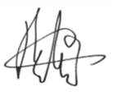
Cllr Richard Coe
Cabinet Member for Household & Regulatory Services
Royal Borough of Windsor & Maidenhead

Cllr Jane Dawson
Cllr Benta Hickley
Chair, Old Windsor Parish Council Chair, Horton Parish Council
Cllr Phil Jackson Cllr David Buckley
Chair, Wraysbury Parish Council Chair, Datchet Parish Council

C.c.
Cllr Simon Werner – Leader of the Council, Royal Borough of Windsor & Maidenhead
Stephen Evans – Chief Executive. Royal Borough of Windsor & Maidenhead

