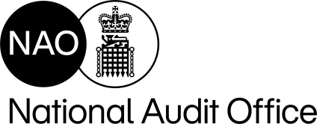**The UK’s independent public spending watchdog**

Switchboard +44 (0)207 798 7000

Direct Line +44 (0)207 798 7840

|  |  |  |
| --- | --- | --- |
|  | Email | Rich.Sullivan-  Jones@nao.org.uk |
|  |  |  |
| Mr Ewan Larcombe ewan.larcombe@mail.com | Date | 30 September 2024 |

Dear Mr Larcombe,

Thank you for your correspondence to the NAO on 5 September 2024. This was passed to me as Director of value for money audit on Defra and the Environment Agency (EA). You set out two concerns relating to:

* a lack of maintenance by EA of existing flood defences, particularly a lack of dredging of the Thames; and
* the River Thames Flood Defence scheme’s increased cost despite a reduction in project size and concerns over Defra’s partnership funding policy affecting the project.

We have not done any work specifically on dredging of the Thames, but as you may be aware we did publish a report on [Resilience to Flooding](https://www.nao.org.uk/reports/resilience-to-flooding/) in November 2023 which examined Defra’s and EA’s approach to the issues you highlight at a system level.

The report found (paragraph 22) that EA is not maintaining its flood defences to a level that optimises value for money, due to a shortfall in its maintenance funding. EA has assessed that maintaining 98% of high consequence flood assets at their required condition will provide optimal value for money, and this would require additional investment. In summer 2023 only 93.5% of EA’s assets in high consequence systems were being maintained at the required condition, below the 94-95% level agreed with Defra in the 2021 Spending Review settlement. This meant that, as at summer 2023, 203,000 properties were at increased flood risk because more EA assets are below the required condition than planned. We make a recommendation about the maintenance budget at paragraph 27.

Inflation has also affected EA’s flood and coastal defence capital investment programme (2021 to 2027), affecting the cost and viability of projects (paragraph 17 and 2.16). EA’s original assumption for inflation across the six years of the capital investment programme (4% a year) was significantly below EA’s updated flood-specific inflation forecast (as at the time of our report) of an average of 6.3% a year. EA estimates that inflation is the cause of between a half and two-thirds of the reduction in the forecast number of properties better protected by the capital investment programme.

The report also found that partnership funding is one of several risks that could prevent EA better protecting 200,000 properties by 2027 (paragraph 20). This target was already revised down from the original 336,000 properties target for the capital investment programme. In July 2023, EA estimated that £800 million of partnership funding was yet to be secured for the programme. We make recommendations about the partnership funding policy at paragraph 28.

The NAO monitors how departments are responding to all our recommendations and publishes some information in our [recommendations tracker.](https://www.nao.org.uk/recommendations-tracker/) You may also be interested to see, if you have not already, the Public Accounts Committee (PAC) [report](https://committees.parliament.uk/publications/42888/documents/213370/default/) which resulted from a session based on our 2023 report. The government’s response to, and progress in implementing, PAC recommendations is published in [HM Treasury Minutes reports.](https://www.gov.uk/government/collections/treasury-minutes)

157-197 Buckingham Palace Road, Victoria, London SW1W 9SP

020 7798 7000 www.nao.org.uk

Cert No. 8835

ISO 14001

Resilience to flooding is a subject we return to regularly and monitor on an ongoing basis. Your correspondence is a valuable contribution to our ongoing understanding of the issues relating to this area, and to our follow-up work with Defra and EA in how they are taking forward our recommendations.

Thank you again for contacting us.

Yours sincerely

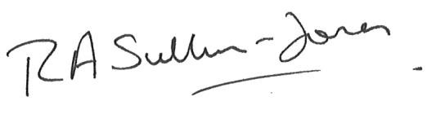

Rich Sullivan-Jones

**Director, Defra VFM**