**Black Potts footbridge joint images –**

**Recording significant timber deterioration between 2024 and 2025**

From Inspection report 2024 East end – South side

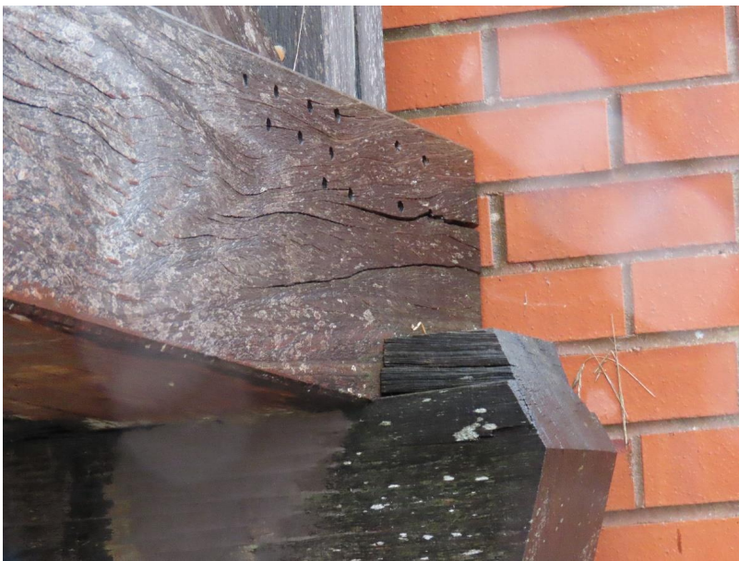

June 2025

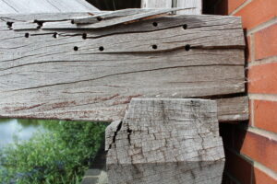

From Inspection report 2024 Centre span – South side

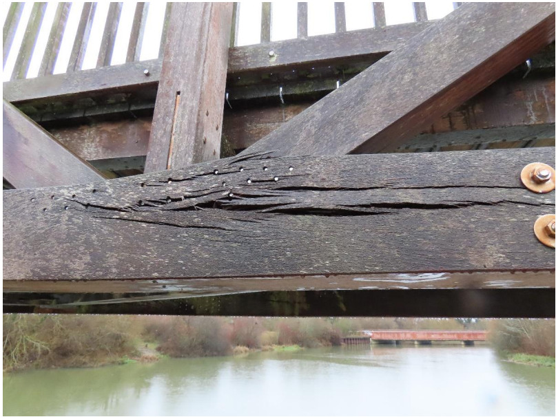

June 2025

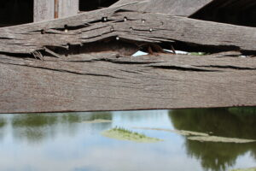

From Inspection report 2024 Centre span – South side



June 2025 Centre span – South side

