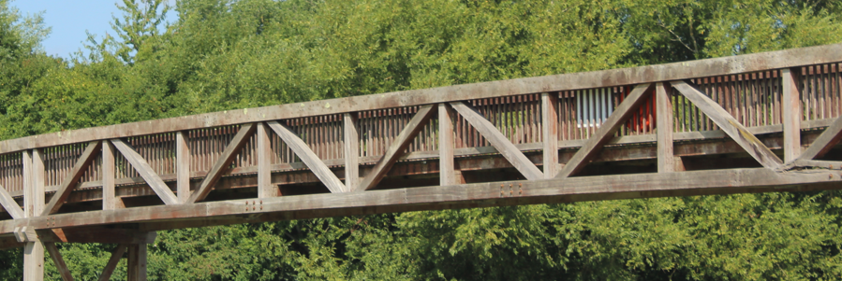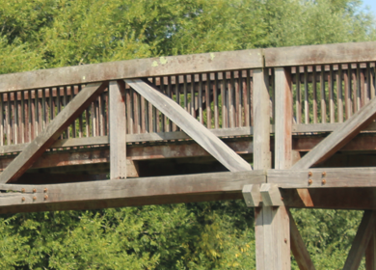

<https://pghbridges.com/basics.htm>

**Truss - Warren variations**

A **Warren truss**, patented by James Warren and Willoughby Monzoni of Great Britain in 1848, can be identified by the presence of many equilateral or isoceles triangles formed by the web members which connect the top and bottom chords. These triangles may also be further subdivided. Warren truss may also be found in covered bridge designs.

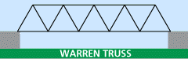

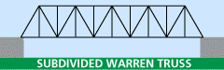

**Black Potts Footbridge Structural Analysis**

**Subdivided Warren/Fink Truss - 10 Bay Configuration**

**Design Parameters & Assumptions:**

* **Truss Type:** Subdivided Warren Truss / Fink Truss configuration
* **Structure:** 10 rectangular bays, 1.5m high × 2m long each
* **Total span:** 20m
* **Total dead load:** 10 tonnes (1000 kg/m distributed)
* **Live load:** 5 kN/m² (pedestrian loading to BS EN 1991-2)
* **Material:** Timber construction
* **Support conditions:** Simply supported at ends
* **Load combination:** Dead Load + Live Load (critical case)
* **Truss characteristic:** Alternating diagonal pattern typical of Warren/Fink design

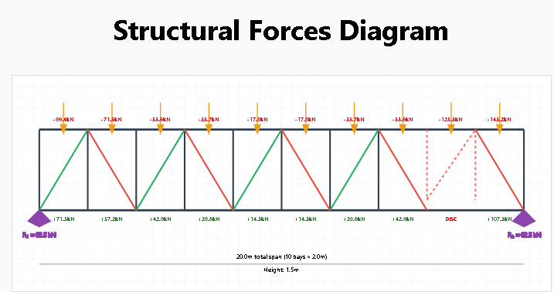

**Structural Forces Diagram**

R₁ = 62.5 kNR₂ = 62.5 kN-89.4kN-71.5kN-53.6kN-35.7kN-17.8kN-17.8kN-35.7kN-53.6kN-125.3kN-143.2kN+71.5kN+57.2kN+42.9kN+28.6kN+14.3kN+14.3kN+28.6kN+42.9kNDISC+107.3kN20.0m total span (10 bays × 2.0m)Height: 1.5m

**Compression (-)**

**Tension (+)**

**Critical Members**

**Dead Load (DL)**

**10 tonnes total**

1000 kg/m distributed = 9.81 kN/m

Point loads at nodes: 9.81 kN each

**Live Load (LL)**

**Pedestrian Load**

5 kN/m² × 2m width = 10 kN/m

Point loads at nodes: 10 kN each

| **Member Type** | **Bay Location** | **Force (kN)** | **Type** | **Utilization** | **Notes** |
| --- | --- | --- | --- | --- | --- |
| **Top Chord** | **End Bay (10)** | **-143.2** | **Compression** | **CRITICAL** | **Maximum compression due to discontinuity** |
| **Top Chord** | **Bay 9** | **-125.3** | **Compression** | **CRITICAL** | **High compression near discontinuity** |
| **Top Chord** | **Bays 1-8** | **-17.8 to -89.4** | **Compression** | **MODERATE** | **Normal distribution pattern** |
| **Bottom Chord** | **Bay 10** | **+107.3** | **Tension** | **CRITICAL** | **Maximum tension due to load redistribution** |
| Bottom Chord | Bay 9 | **DISCONNECTED** | N/A | FAILED | No load transfer - structural discontinuity |
| **Bottom Chord** | **Bays 1-8** | **+14.3 to +71.5** | **Tension** | **MODERATE** | **Normal distribution pattern** |
| **Verticals** | **Connected posts (1-8,11)** | **+12.5** | **Tension** | **LOW** | **Load transfer members** |
| Verticals | Posts 9 & 10 | **ZERO** | N/A | INACTIVE | Disconnected - carry no load |
| **Diagonals** | **Active bays (1-8,10)** | **+44.7** | **Mixed** | **MODERATE** | **Normal Warren pattern** |
| Diagonal | Bay 9 | **ZERO** | N/A | INACTIVE | Disconnected - no load transfer |

**⚠️ CRITICAL Structural Concerns & Recommendations:**

* **STRUCTURAL DISCONTINUITY:** The disconnection at bay 9 creates a major structural weakness. Loads from the disconnected section must be carried by adjacent members, causing significant stress concentrations.
* **Critical Overloading:** Top chord in bay 10 now carries -143.2 kN (60% increase from normal) due to load redistribution from the disconnected section.
* **Bottom Chord Overstress:** Bay 10 bottom chord experiences +107.3 kN tension (50% increase) as it must bridge the discontinuity.
* **Load Path Failure:** Posts 9 & 10 and diagonal 9 are structurally inactive, creating an effective "gap" in the truss that concentrates all loads onto bay 8 and bay 10 connections.
* **Connection Failure Risk:** The connections at posts 8 and 11 are now critical points carrying redistributed loads from the failed section.
* **Progressive Failure Potential:** This discontinuity could lead to progressive collapse if adjacent members become overloaded.
* **IMMEDIATE ACTION REQUIRED:** This bridge should be considered structurally compromised and potentially unsafe for public use.

**Analysis Notes:**

This analysis is based on a **Subdivided Warren Truss** (also known as a Fink Truss) configuration with alternating diagonal members. This truss type is highly efficient for moderate spans, with the diagonal members working alternately in compression and tension. The pattern creates excellent load distribution but requires careful attention to compression diagonal buckling - a characteristic weakness of Warren-type trusses.

**Warren/Fink Truss Advantages:** Efficient material usage, good load distribution, relatively simple fabrication

**Warren/Fink Truss Disadvantages:** Compression diagonals prone to buckling, requires robust connections at panel points

**Recommend:** Detailed inspection of compression diagonal buckling capacity, end connection integrity, and consideration of strengthening or replacement given the structure's reported condition and the inherent buckling vulnerabilities of Warren-type trusses.