Jubilee River Issues - images @ 9/9/2025
Myrke embankment
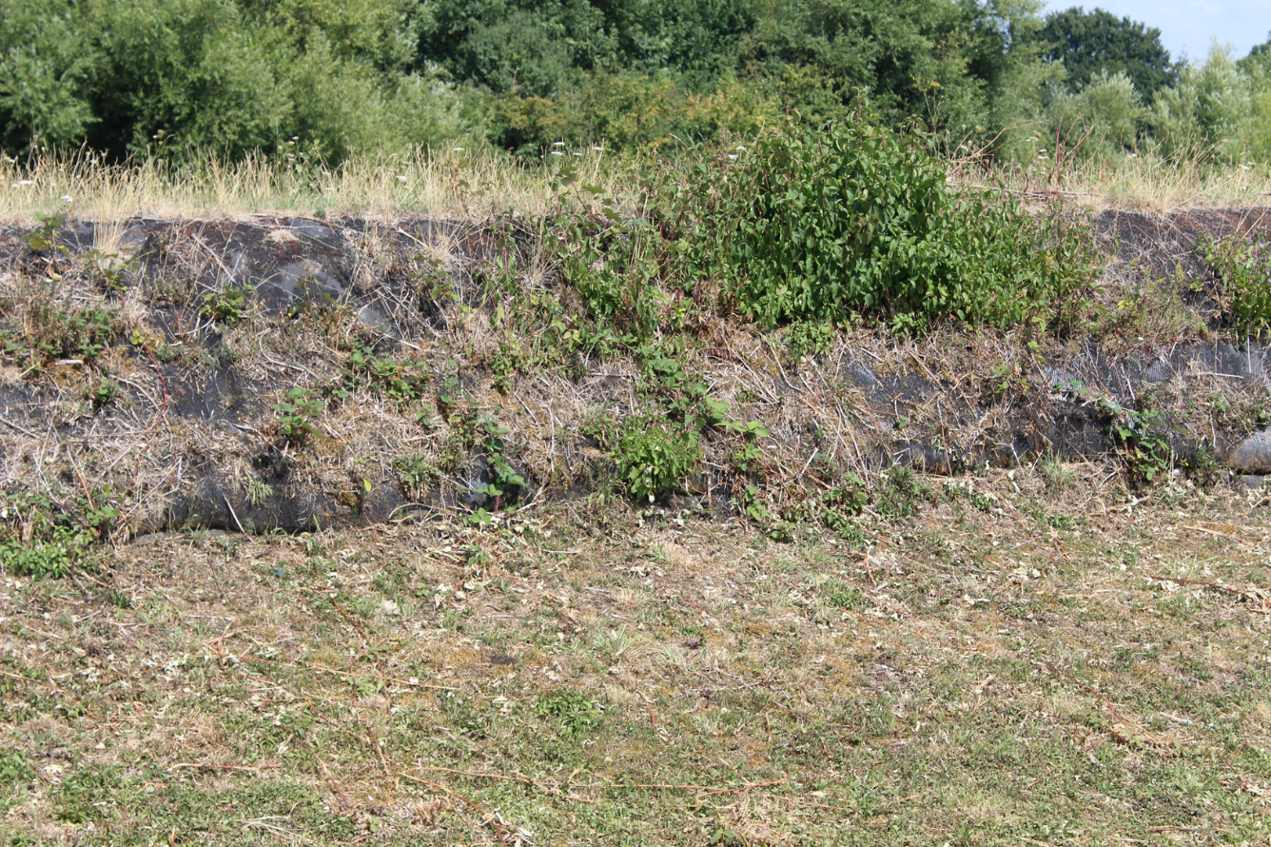

Myrke embankment
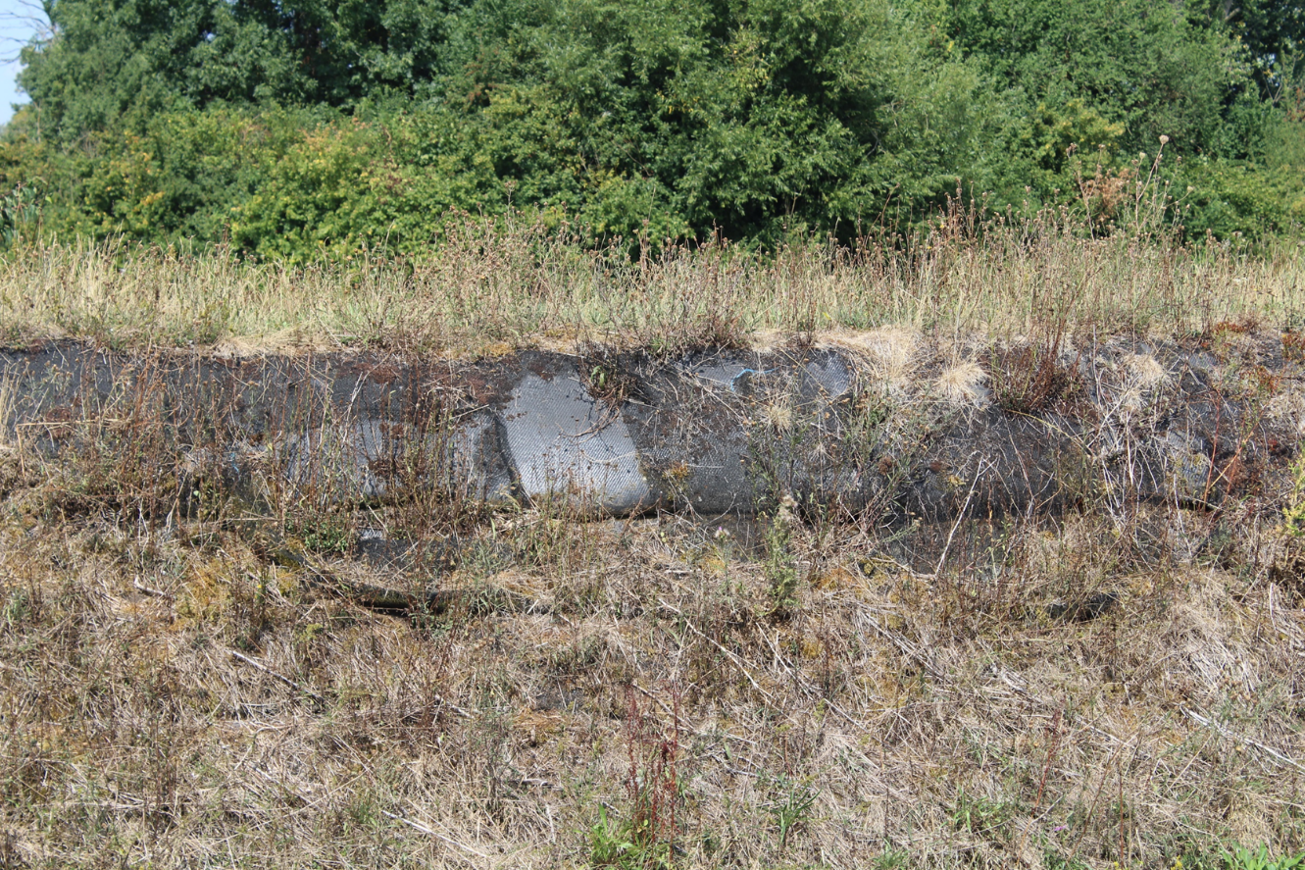
Taplow Scour showing temporary repair
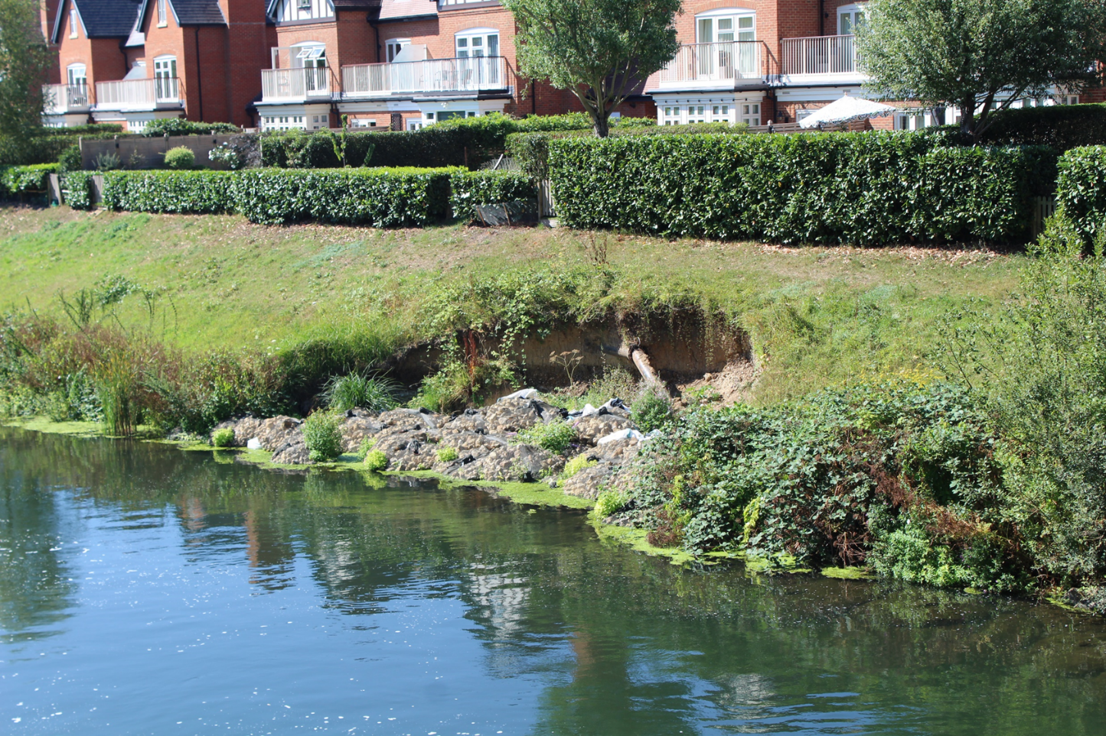

Ashford Lane footbridge (collapsed)
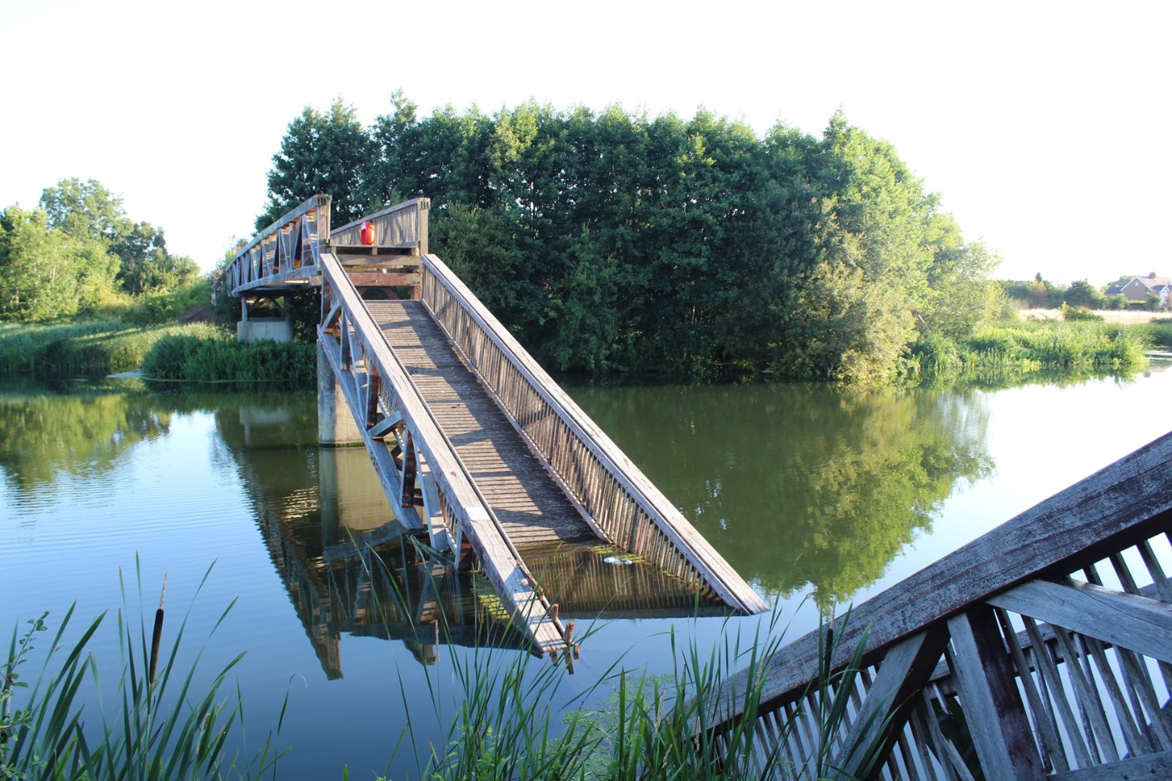
Black Potts footbridge (closed July 2025)
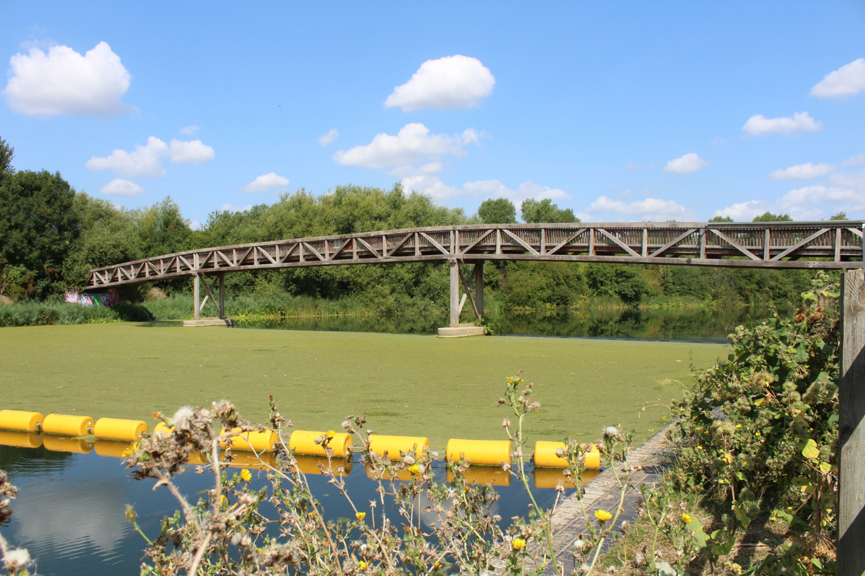

Black Potts footbridge – centre span structural issue
