**Wraysbury Drain Report – Ewan Larcombe - 9/11/2020**

For the sake of clarity the map below illustrates what I believe to be the Wraysbury Drain marked in red.

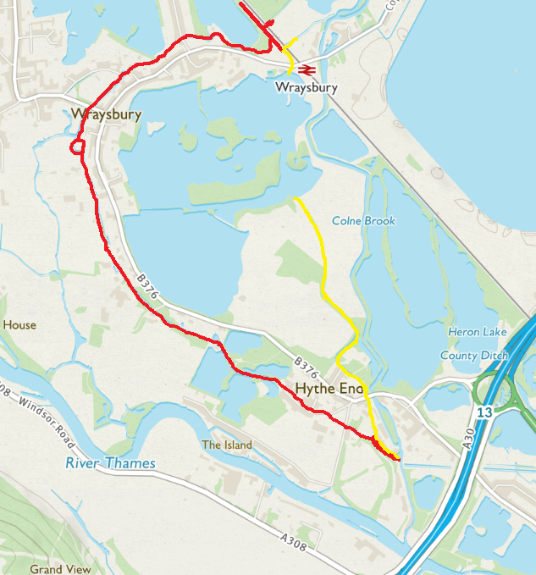

The only recent RBWM maintenance actions to my knowledge have been the repair of the weir at Wraysbury Station in July 2019 and the occasional clearance of fly tipped materials at Feathers Lane.

**Station Road**

The Wraysbury Drain is an important element of the local land drainage infrastructure but is lacking maintenance at Station Road, Wraysbury and has not flowed properly for some time.

When I last looked the relatively new (30 years since construction) channel at Station Road is narrow, overgrown with trees, fenced with barbed wire and difficult even to view let alone access. The main upstream problem section (about 300m in length) is marked in red on the map below. The channel extends from the junction upstream of the weir (at the railway line) and downstream to a point beyond the Wraysbury Dive Centre access bridge where the channel is blocked with gravel. It is a matter of record that the riparian owners have been unhelpful in the past.

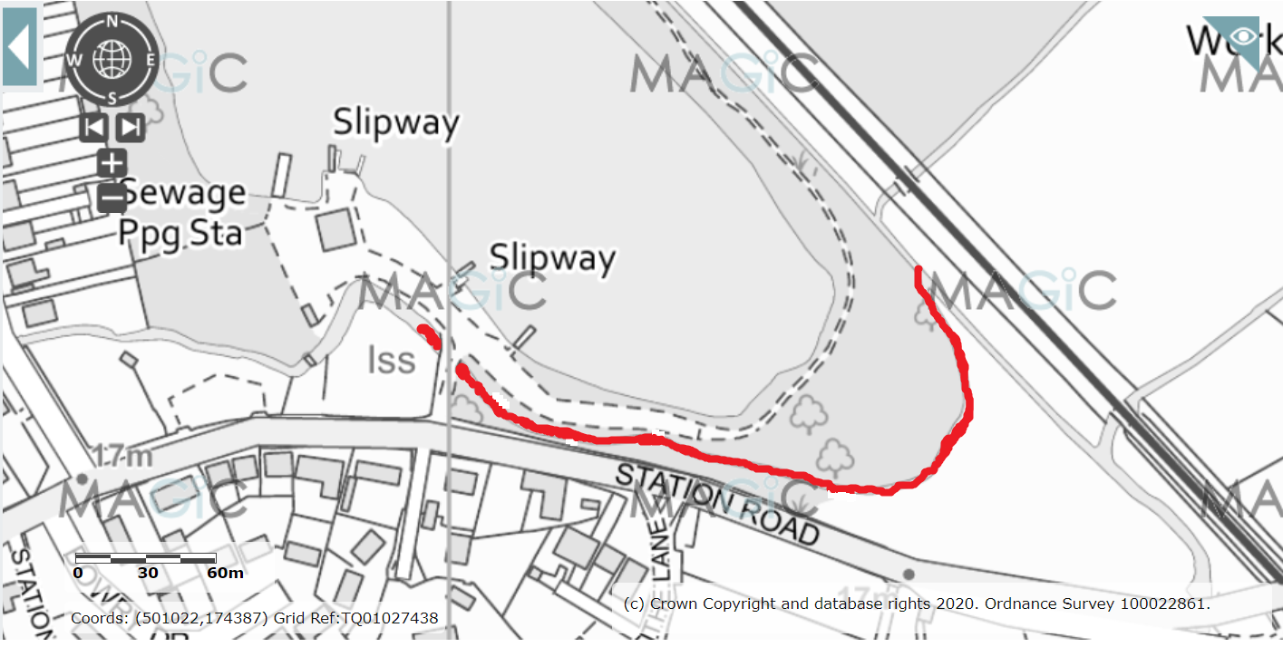

Maintenance of the Station Road section should immediately restore flow in the upper section of the Wraysbury Drain.

**Feathers Lane**

The Wraysbury Drain is lacking maintenance at Feathers Lane and Hythe End Road, Wraysbury and has not flowed properly for some time. This is the main downstream problem. I have marked up the map below. When I last looked the channel has been blocked and fenced over at Feathers Lane.

I first reported this blockage in early 2019. The channel has been culverted without permission downstream towards Hythe End Road. The channel has been screened beneath the palisade fencing at Hythe End Road. The protective barrier on Hythe End Road has collapsed and there may be issues further downstream.

The blockage (image below dated May 2019) needs clearing as a matter of urgency. I believe the entire length of this section of the channel from the confluence with the Horton Drain and upstream (beyond Feathers Lane) to the gravel pit (accessed from Staines Road) needs to be inspected in order to identify further issues.

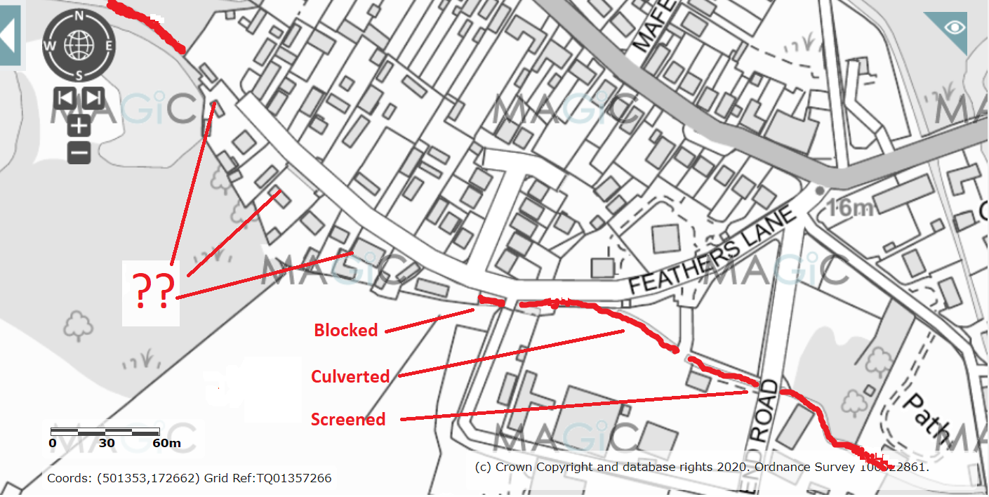

**Feathers Lane – May 2019**

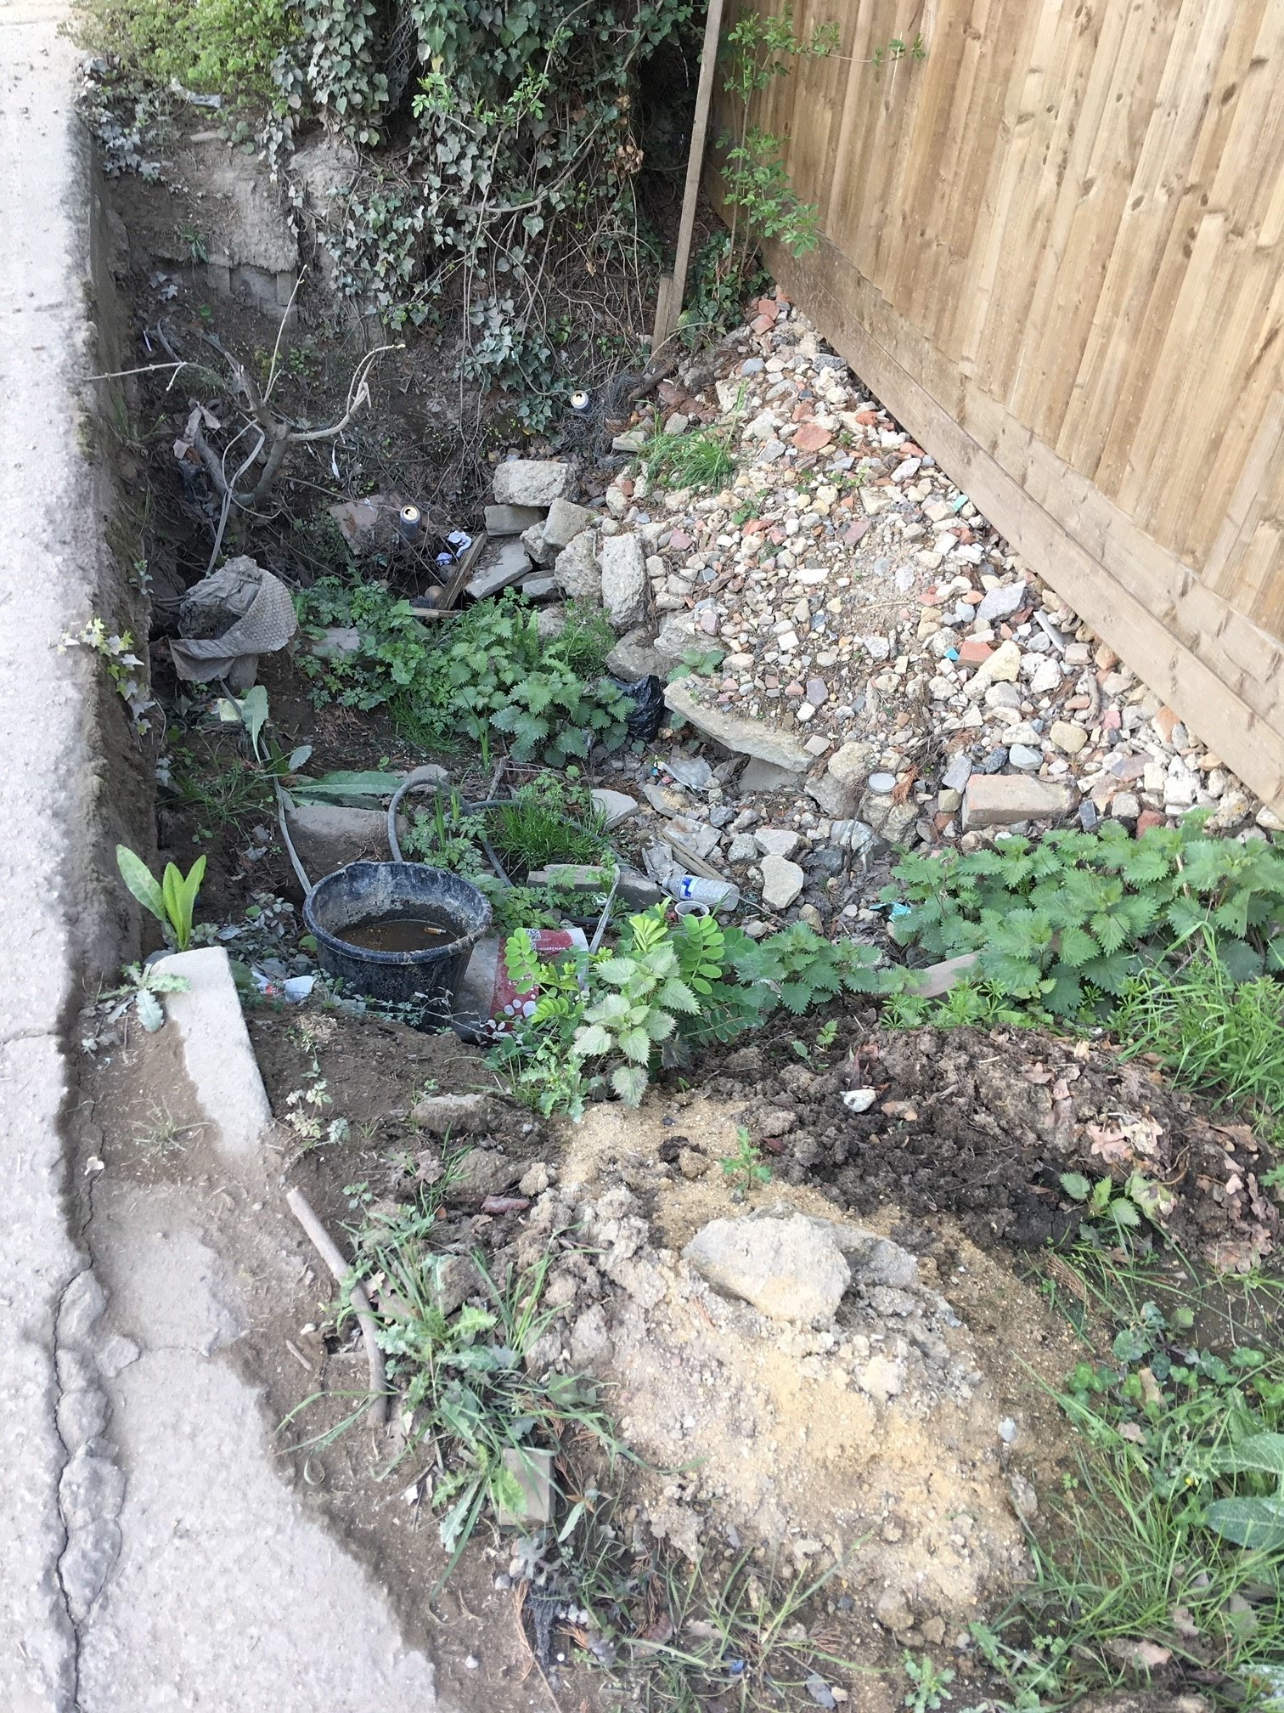

END