Evidence Report on Public Disclosure of Confidential Council Papers
DHWNEWS publication recorded on 28 October 2026
Prepared for review by Datchet Parish Council

Executive Summary
On 28 October 2026, the publicly accessible DHWNEWS post at https://dhwnews.com/?p=4498 displayed direct links to Datchet Parish Council agenda papers 26/163 and 26/164. Both downloaded papers carry a prominent diagonal CONFIDENTIAL watermark on every inspected page. The post and both files were accessible without a sign-in.
The papers concern an extraordinary council meeting held on 21 October 2026. They discuss legal proceedings, security arrangements, proposed funding and estimated expenditure. Agenda item 26/164 includes a financial schedule totalling £68,801.50. The screenshots in this report record the public disclosure and the documents' own confidentiality markings.
This evidence establishes public availability at the time of capture. It does not determine who uploaded the files, whether publication was authorised, or whether the statutory test for a reportable personal data breach is met. That assessment should be completed by the Council's responsible officer or data protection adviser after reviewing the full documents, the people and data affected, access logs and the duration of publication.

Verified Findings
- The DHWNEWS post is dated 28 October 2026 and expressly uses the word confidential in its title.
- The post contains direct links labelled Agenda item 26/163 and Agenda item 26/164.
- The linked PDF files were accessible without authentication and were downloaded from public DHWNEWS URLs.
- Agenda item 26/163 is a three-page Datchet Parish Council report dated 17 October 2026. Each rendered page carries a diagonal CONFIDENTIAL watermark.
- Agenda item 26/164 is a two-page Datchet Parish Council report dated 17 October 2026. Each rendered page carries a diagonal CONFIDENTIAL watermark.
- Agenda item 26/164 sets out received, proposed and potential costs and records a total of £68,801.50.

Assessment
The evidence supports treating the publication as a confidentiality and information-security incident requiring immediate containment and formal assessment. A personal data breach under UK GDPR requires accidental or unlawful destruction, loss, alteration, unauthorised disclosure of, or access to, personal data. The presence of confidential markings alone does not decide that legal question, but the public availability of council papers marked CONFIDENTIAL is a clear basis for escalation and investigation.

Screenshot Evidence
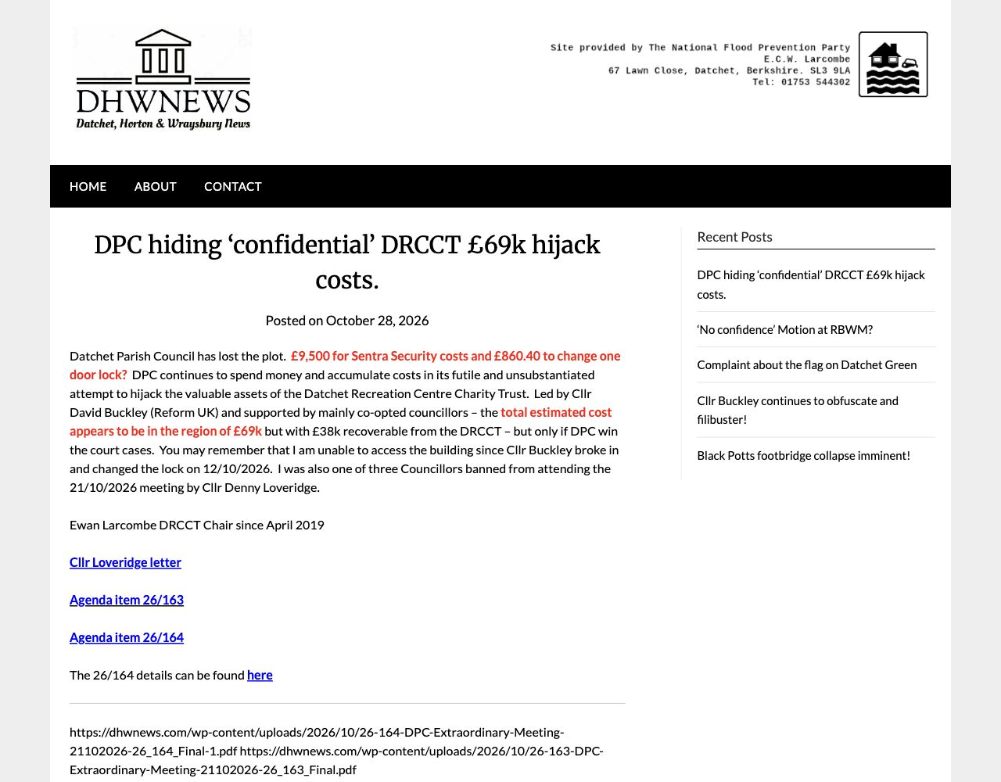
Figure 1 DHWNEWS post showing the publication date and direct links to agenda items 26/163 and 26/164
Source: https://dhwnews.com/?p=4498 Accessed 28 October 2026 without authentication.
The screenshot records the site identity, article title, publication date and the two agenda-item links. The full direct PDF URLs are also printed beneath the links on the live page.

Agenda Item 26 163
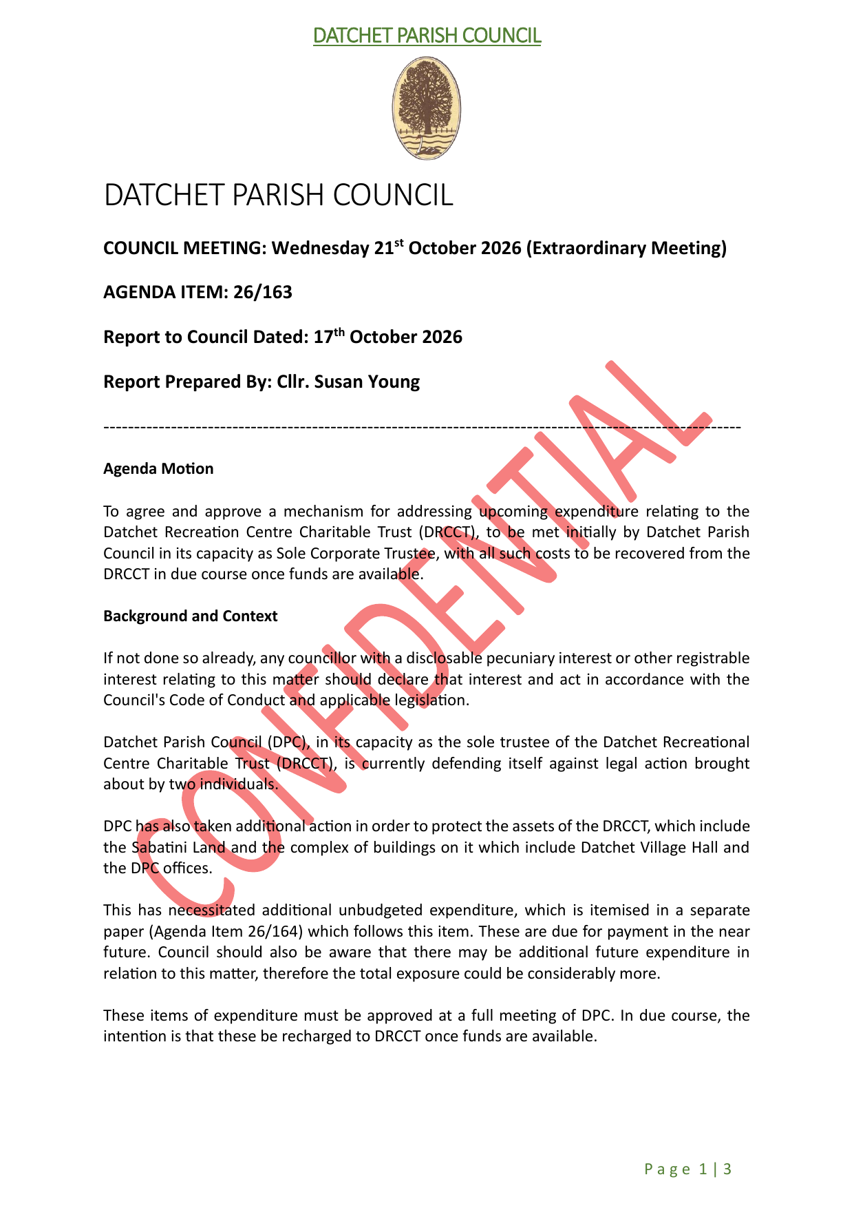
Figure 2 First page of agenda item 26/163 showing the council heading, meeting details and CONFIDENTIAL watermark
Source: https://dhwnews.com/wp-content/uploads/2026/10/26-163-DPC-Extraordinary-Meeting-21102026-26_163_Final.pdf Accessed 28 October 2026 without authentication.

Agenda Item 26 164
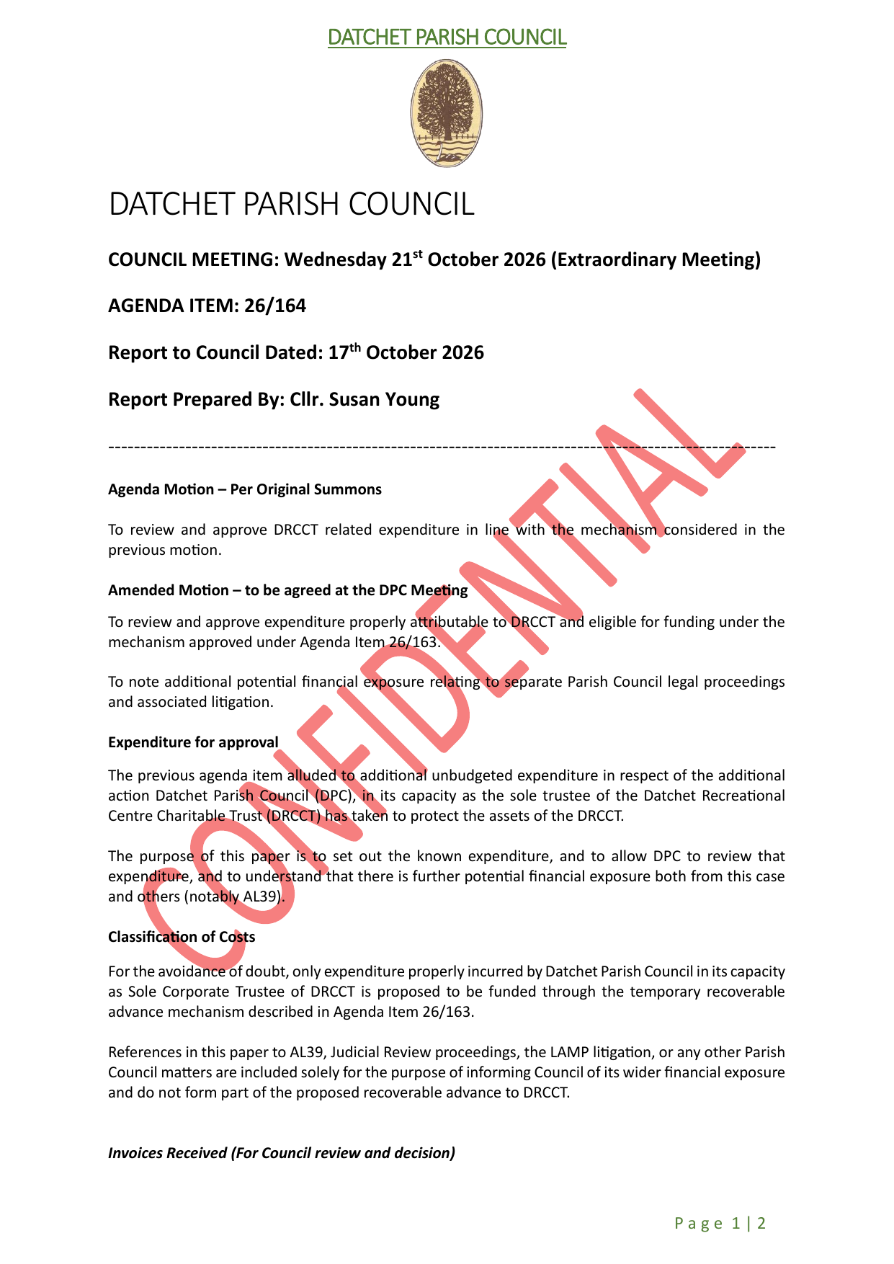
Figure 3 First page of agenda item 26/164 showing the council heading, meeting details and CONFIDENTIAL watermark
Source: https://dhwnews.com/wp-content/uploads/2026/10/26-164-DPC-Extraordinary-Meeting-21102026-26_164_Final-1.pdf Accessed 28 October 2026 without authentication.

Financial Schedule Published in Agenda Item 26 164
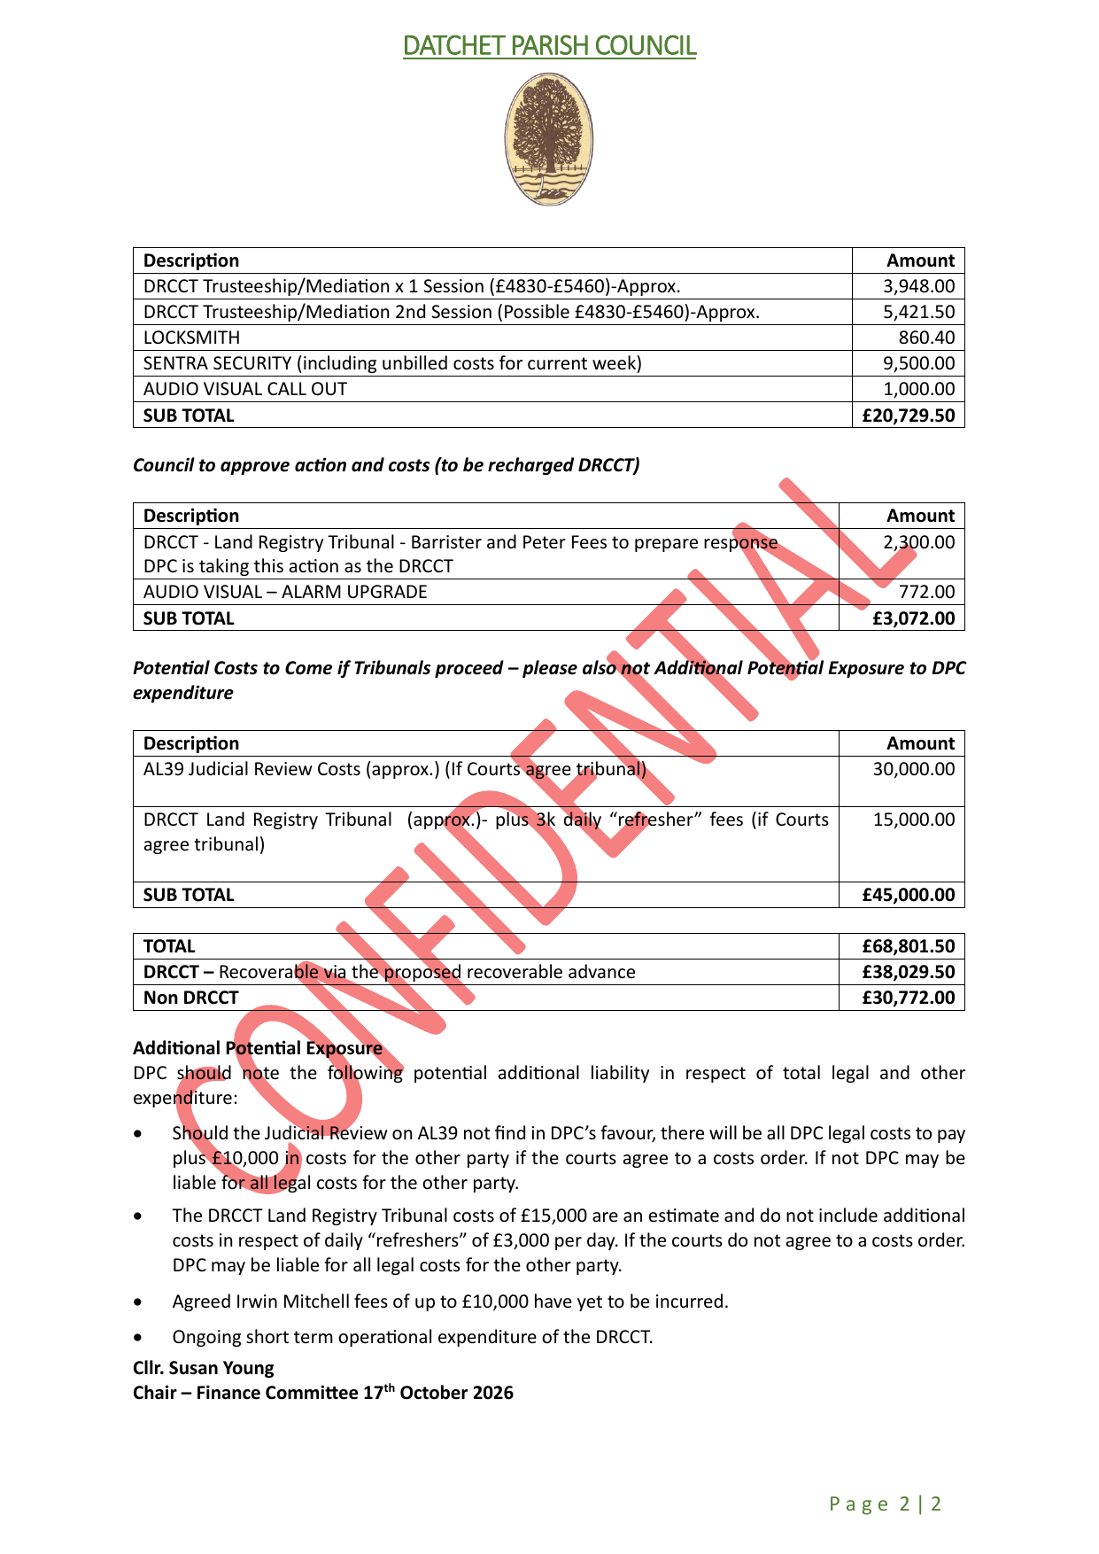
Figure 4 Second page of agenda item 26/164 showing published cost details and the CONFIDENTIAL watermark
Source: https://dhwnews.com/wp-content/uploads/2026/10/26-164-DPC-Extraordinary-Meeting-21102026-26_164_Final-1.pdf Accessed 28 October 2026 without authentication.

Recommended Immediate Actions
- Record the discovery time and preserve the webpage, PDFs, URLs, file hashes and relevant server or sharing logs.
- Ask the site operator and any linked storage provider to remove public access while preserving evidence of publication and access.
- Notify the Clerk, Chair and the Council's data protection contact and begin the Council's breach-response process.
- Identify all personal data, confidential legal material and commercially sensitive information in the published files, together with the people affected and likely consequences.
- Document the risk assessment and the decision on ICO notification. If a personal data breach is likely to risk individuals' rights and freedoms, the ICO says it must be reported without undue delay and, where feasible, within 72 hours of awareness.
- If the assessed risk to affected individuals is high, inform them without undue delay and explain the likely consequences and mitigating steps.
- Review how the files left controlled storage, who authorised publication, how long they were public and whether copies remain indexed, cached or shared elsewhere.

Evidence Integrity Record
Evidence item | Pages | SHA 256
DHWNEWS post screenshot | 1 image | 77c55a91846222c12b0ef3608bc6d9323a28d54eb407cb687c33547c12643822
Agenda item 26/163 | 3 | 50647619841ee797e902b0210fbab0d501b4739c78484dc1df07728d94f39d54
Agenda item 26/164 | 2 | a7edace2e0bcf7267ff61a812bedcfb0cfd015dee388f4e4b1bbd92aa54ee54d

Reference Guidance
Information Commissioner's Office, Personal data breaches a guide: https://ico.org.uk/for-organisations/report-a-breach/personal-data-breach/personal-data-breaches-a-guide/
Information Commissioner's Office, What is an accidental personal information breach: https://ico.org.uk/for-organisations/uk-gdpr-guidance-and-resources/security/disclosing-documents-to-the-public-securely/what-is-an-accidental-personal-information-breach/

Scope and Limitations
The capture records what was publicly accessible on 28 October 2026. The report does not establish how many people accessed or downloaded the files, whether search engines cached them, the identity or authority of the uploader, or the final legal and regulatory classification of the incident. Those matters require access logs, internal records and a documented risk assessment.

